# What is JMeter

https://jmeter.apache.org/

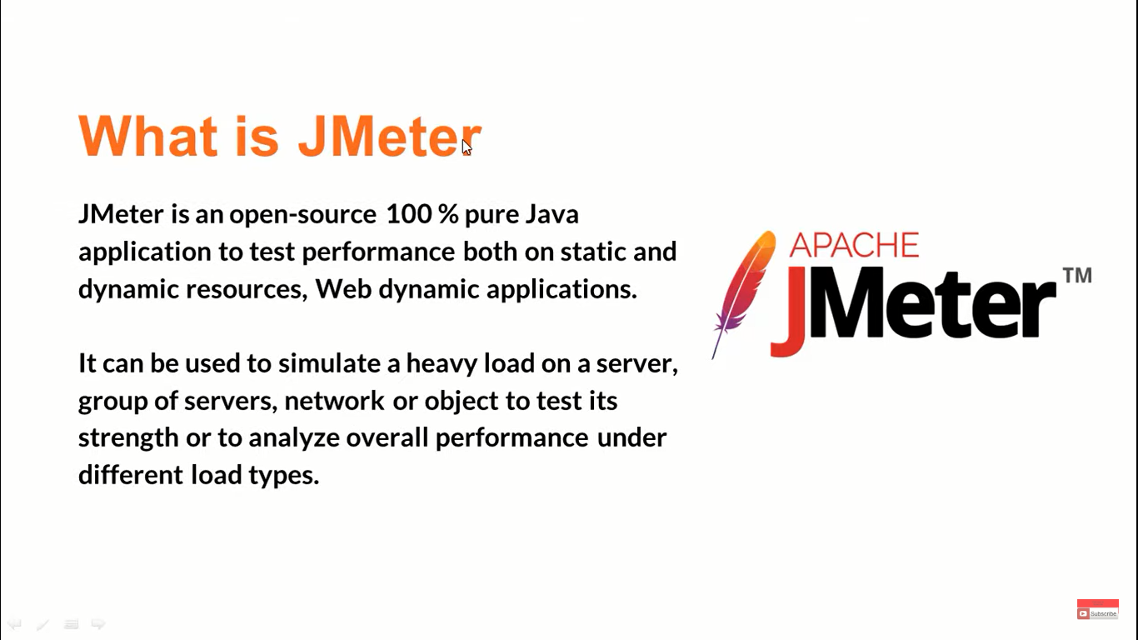

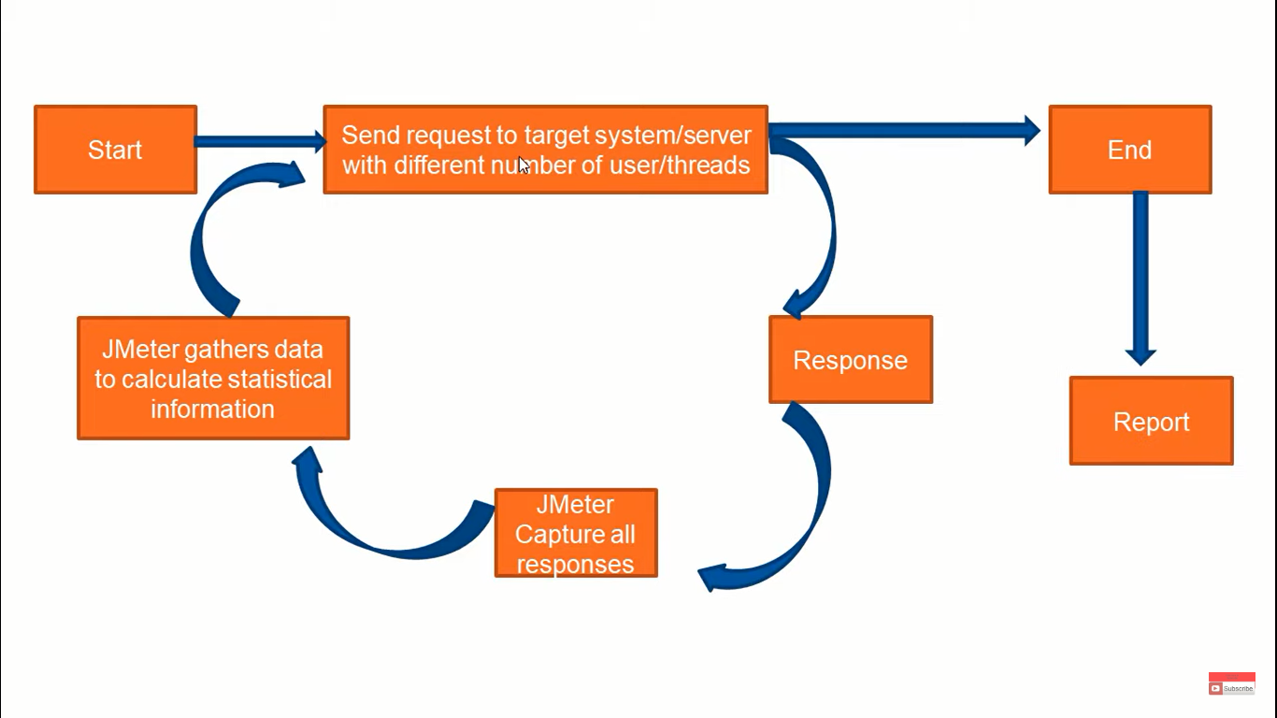

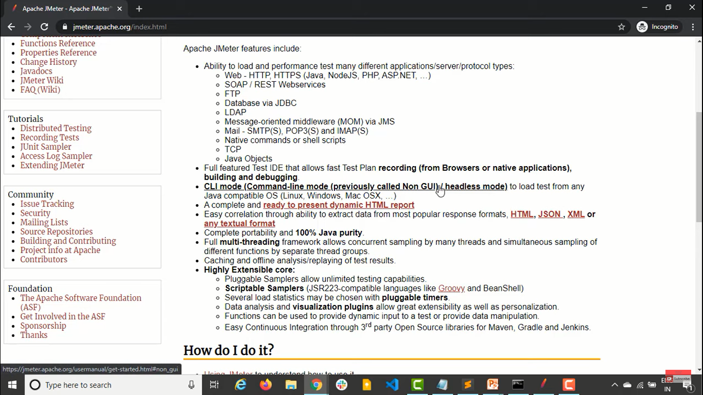

**Samplers ---** are used to send the requests 1 or more

**Logic controllers ---** they determine the order in which the samplers work

**Listeners ---** they listen to the test results

**Configuration elements ---** we can use some variables which can be used in the samplers

**Assertions ---** basically we will be doing some checks that response are coming properly or not

**Timers ---**  JMeter don’t put any timer by default, so we can keep timers using this between each samplers or requests

**Pre processor ---** will be executed before actual sampler or requests

**Post processor ---** these are applied after the sampler or requests

jMeter is an Open Source testing software. It is 100% pure Java application for load and performance testing.

jMeter is designed to cover various categories of tests such as load testing, functional testing, performance testing, regression testing, etc., and it requires JDK 5 or higher

# How to install JMeter

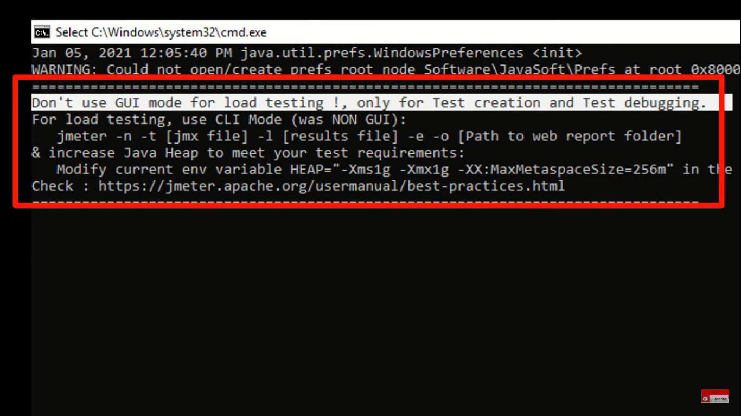

# Quick tour of JMeter

* **Performance Test** − This test sets the best possible performance expectation under a given configuration of infrastructure. It also highlights early in the testing process if any changes need to be made before the application goes into production.
* **Load Test** − This test is basically used for testing the system under the top load it was designed to operate under.
* **Stress Test** − This test is an attempt to break the system by overwhelming its resources.

# How to write first JMeter Script

Click on **NEW** **TEST PLAN** --- **ADD --- THREADS(USERS) --- THREAD GROUP ---** type the file name

Now on the **THREAD – CLICK ON ADD – SAMPLER – TYPE OF THE SAMPLER <HTTP Request>**

**Under server name or ip – Copy the URL which u want to open**

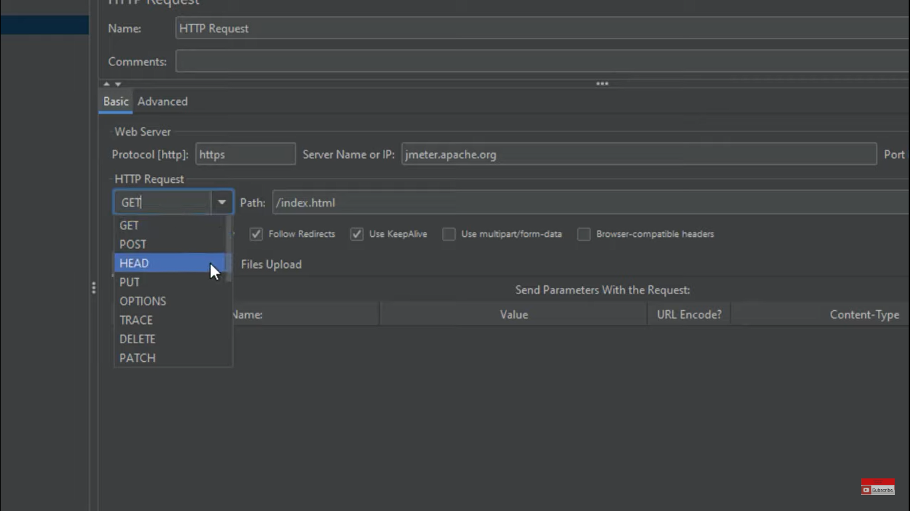

From the above u can see that we created a **HTTP REQUEST** where

Under the PROTOCOL – http

SERVER NAME OR IP -- <THE MAIN URL OR SERVER NAME>

PATH -- <HERE WE GIVE THE PATH OF THE REQUIRED PAGE AS SHOWN IN THE ABOVE PIC>

HTTP REQUEST – WE HAVE LIKE GET – POST – HEAD – PUT - ETC

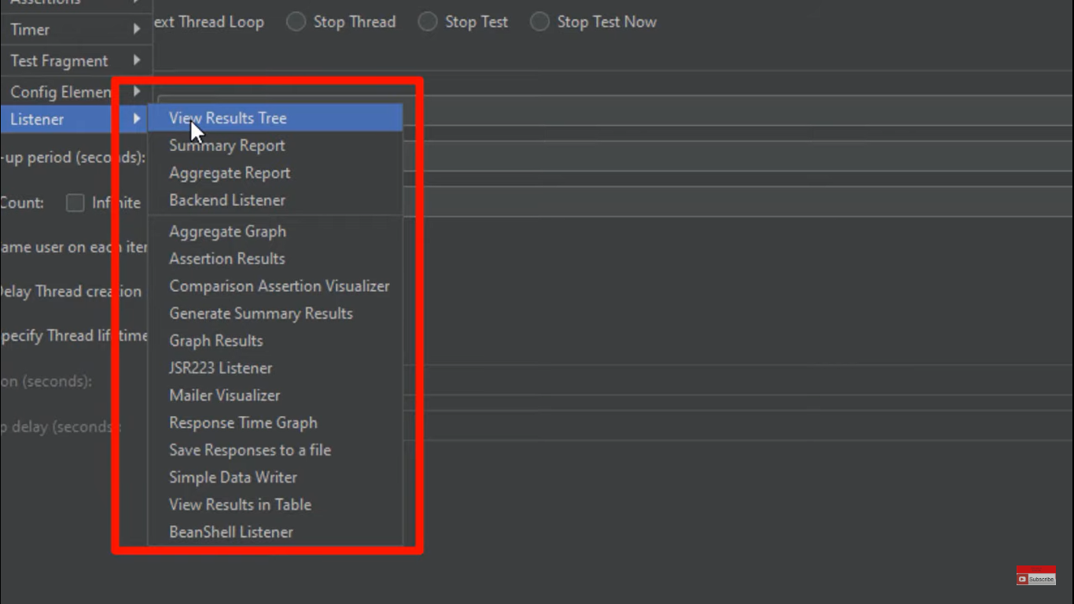

From the above we add LISTENERS i.e to take a note of the RESULT OF THE REQUESTS

VISIT RESULT TREE / VIEW RESULTS IN TABLE – are most commonly used

*********************************************************************

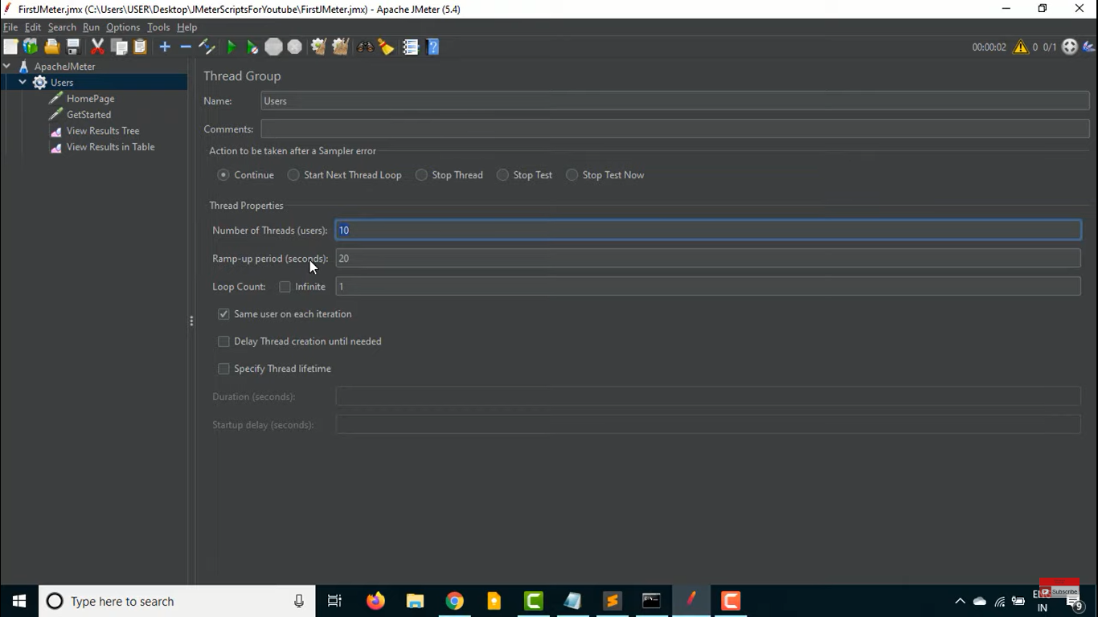

From the above here USERS are nothing but the no. of users hitting the url & SECONDS are in how many seconds the users hit the url

In general USER/SECONDS i.e from the above 10/20 which means 10 users under 20 sec will hit the link i.e for every 2sec 1user will hit the link.

**What if the SERVER NAME OR IP gets changed or updated?**

So we cant go to each and every sample and updated it , to avoid the load of the work we use **USER DEFINED VARIABLES** from the **CONFIG ELEMENT** as shown in below

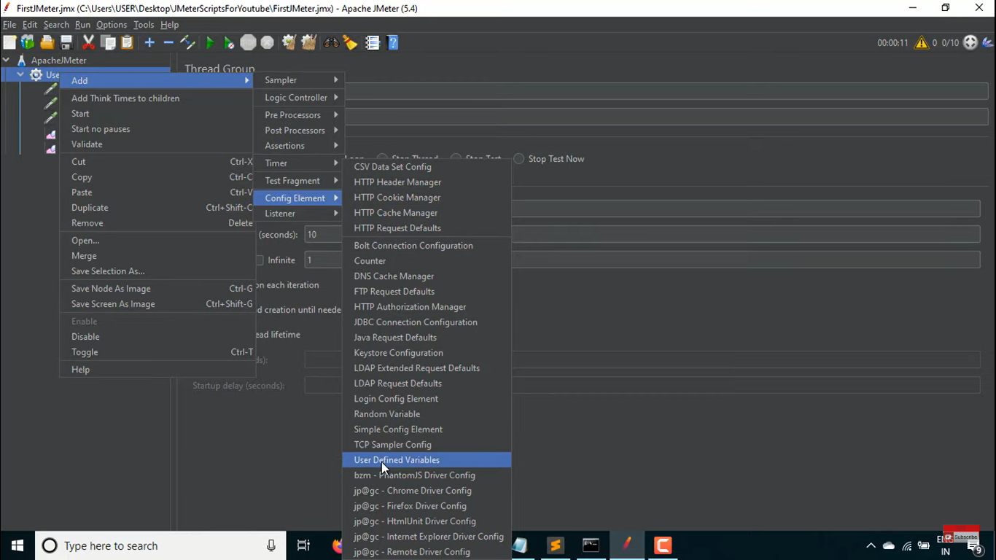

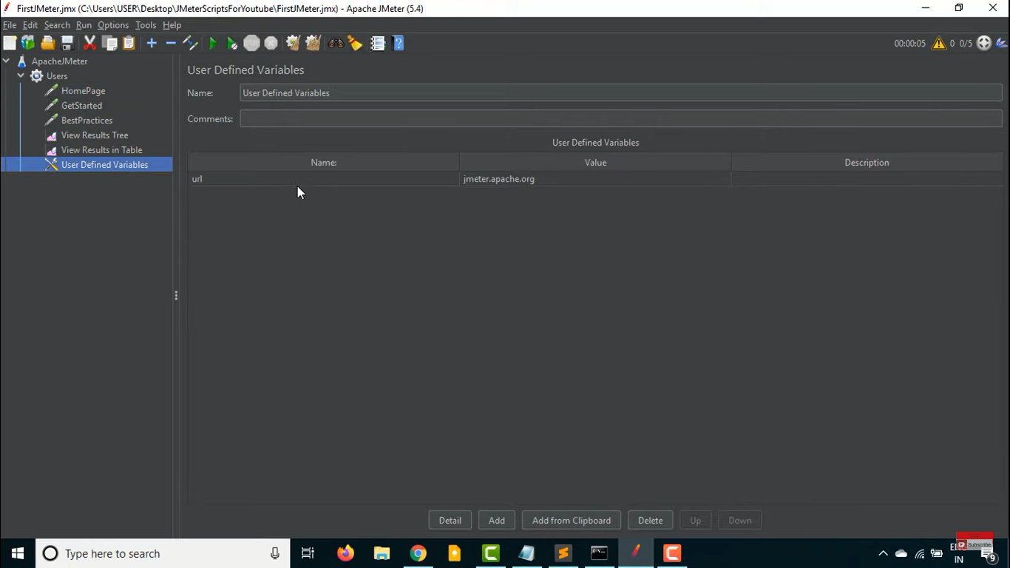

From the above we declared a variable name as **NAME** ,here we have taken URL & under the **VALUE** we give the **SERVER NAME OR IP**  we gave the main link here.

SYNTAX :-- **${variable name}** here example is **${url}**  from the below u can see we have updated it in the SERVER NAME or IP.

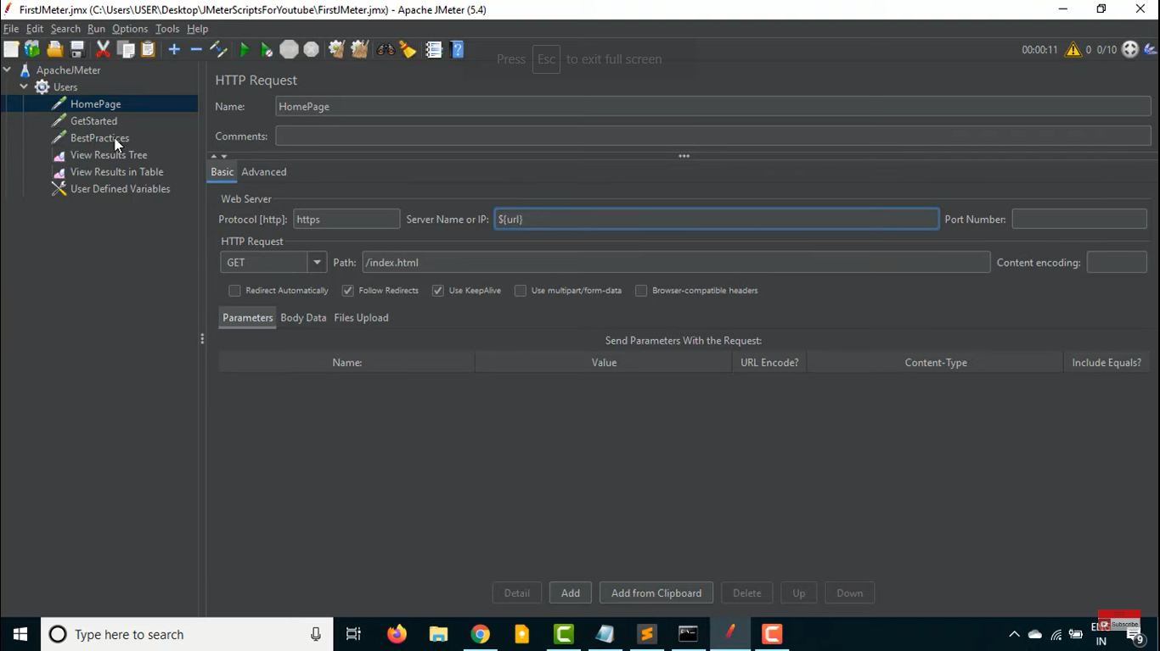

# How To Execute JMeter Script From Command Line JMX from CLI or In Non GUI Mode

# NOTE :-- it is clearly mentioned as shown in the below pic

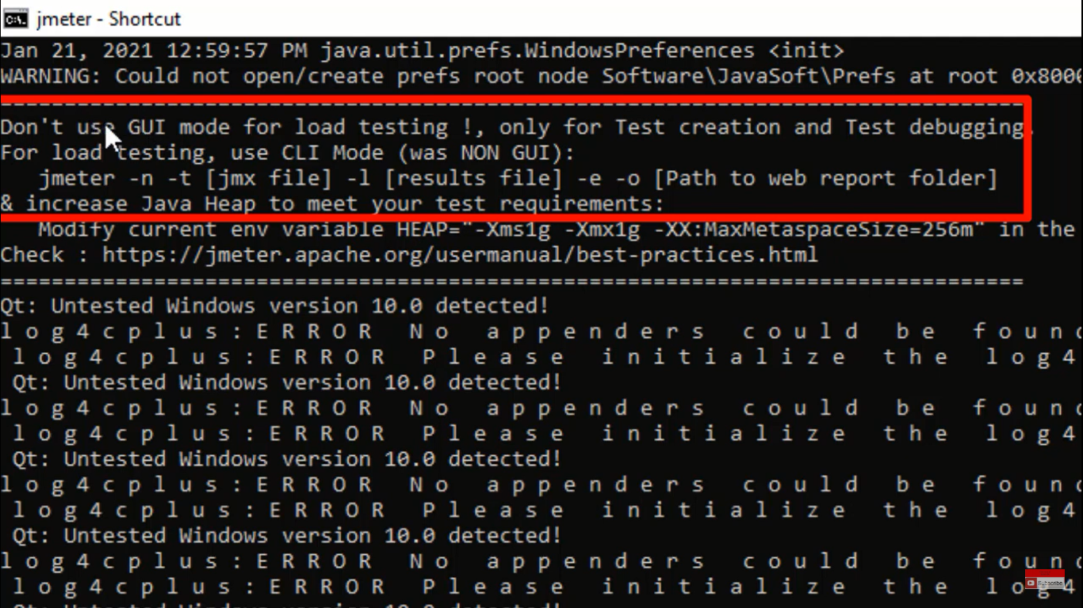

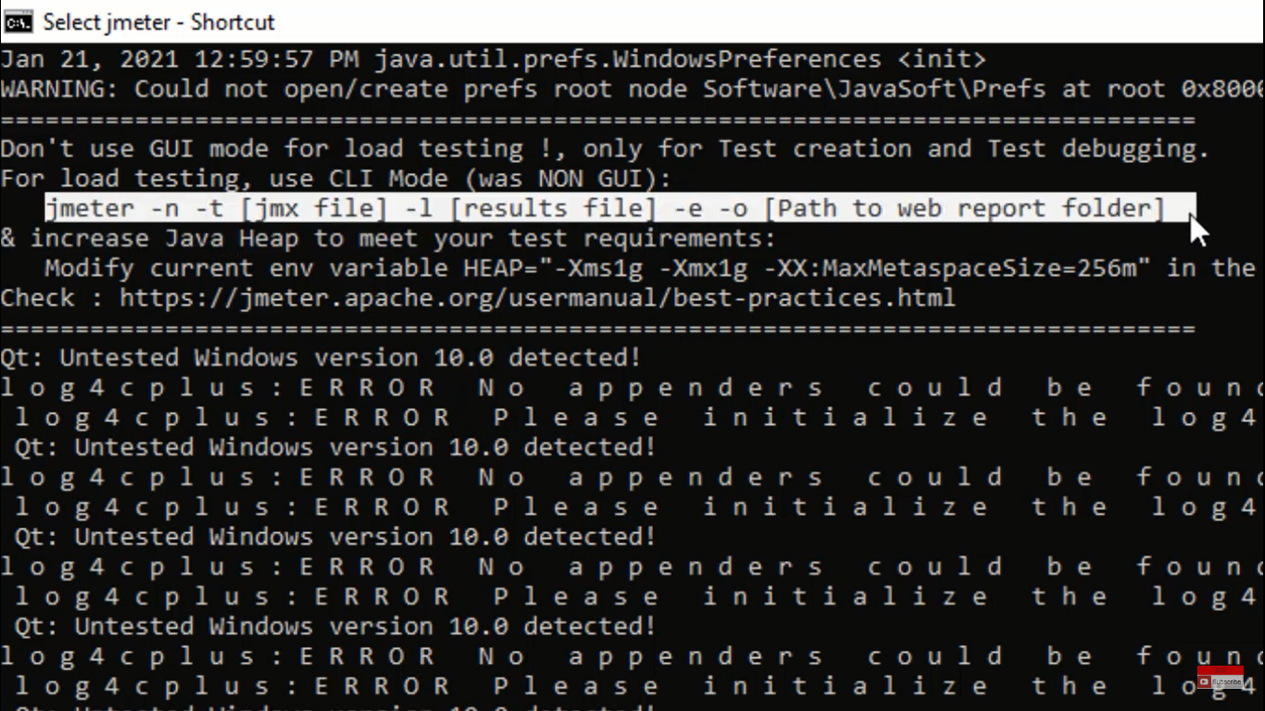

Open the cmd and type

cd D:\apache-jmeter-5.5\bin

cd D:\apache-jmeter-5.5\bin>jmeter -? 🡪 It will show the FLAGS which are available with JMeter

**some of the imp flags are :-**

* -n = non gui mode
* -t = path of the jmx file = for execution
* -l = log file i.e to store the results

SYNTAX OF JMETER TO RUN IN THE COMMAND LINE = **jmeter –n –t <jmx file location>**

